**var keyword**

var keyword stands to variable which considered location memory whose value **may changes** during the execution of a program. We know in [variable](Variables.docx) file how variable in general created, work, and also its syntax.

**Notes:**

1. var statement can stored **primitive | reference** data type.
2. The var keyword is almost the same as [let](let%20keyword.docx). It also declares a variable, but in a slightly different, “old-school” way. Normally we don’t use it.
3. A variable should be declared only once as a repeated declaration of the same variable is an error.
4. var is an optional keyword. (you can declare & initialize variable without it)

**Example 1:**

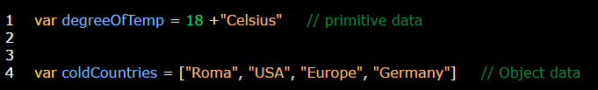

We can use **+** to concatenate several primitive values.

**Example 2:** limitation of concatenation is that you deal with all concatenate values as a one package. Use object data type instead

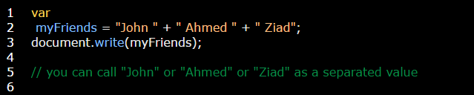

**Example 2:** variable value may changes during the execution of a program (**Remember:** JS is a dynamic language)



On changing the value of a specific identifier the old value was removed from memory location while the new value will be stored instead.

**Example 3:** on declaring of multiline variables:

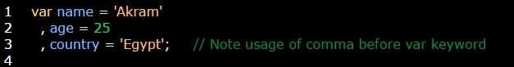

**Example 4:** on declaring identifier twice in the same script.

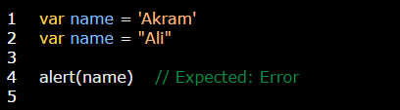

Above example show that there is an identifier declared twice in the same script that means there are two memory locations has the same name and that is impossible.

**Example 5:** variable without var keyword.

